**Module 1 Activity 2: Project Setup**

Anudeep Anisetty

Information Technology, Arizona State University

IFT 554: Middleware Prog & Database Sec

Dinesh Sthapit

January 21, 2024

**Module 1 Activity 2: Project Setup**

**Visual Studio Code Installation Proof.**

***Screenshot 1:****Visual Studio Code application running on the desktop.*

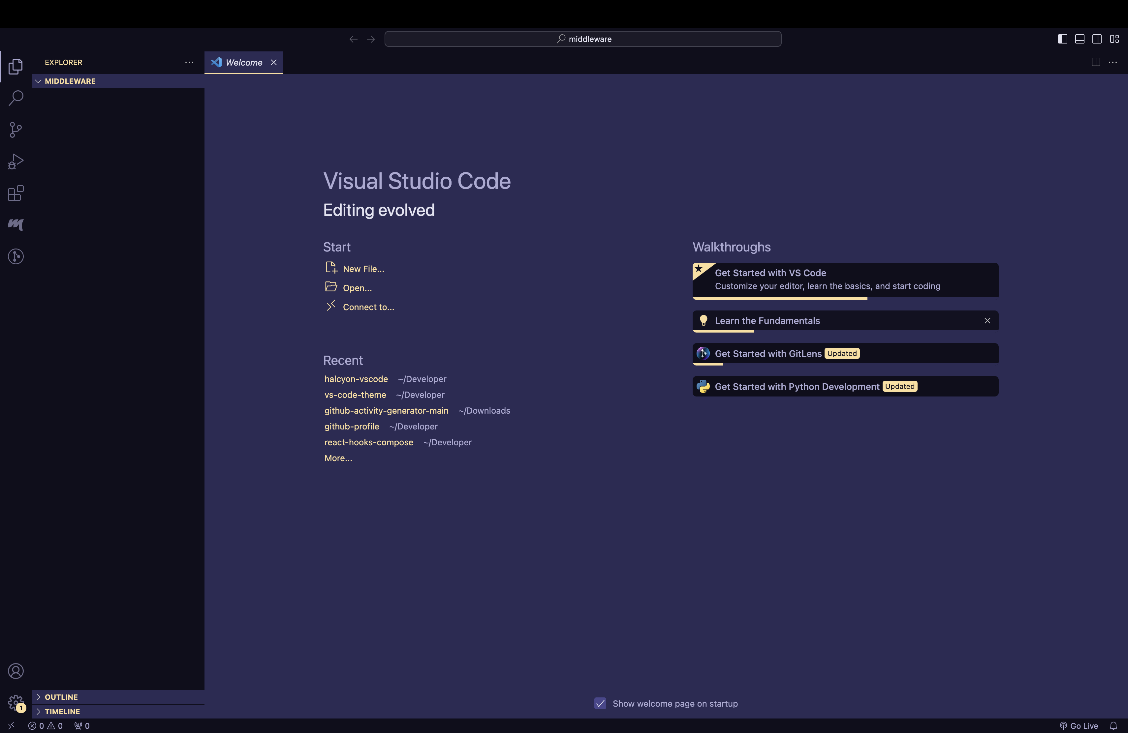

***Node.js Installation Proof:***

* ***Screenshot 2:****Terminal window opened in Visual Studio Code.*

* ***Screenshot 3:****Execution of the command node -v displaying the Node.js version.*

* ***Screenshot 4:****Execution of the command npm -v displaying the npm version.*

***Workspace and Project Directory Creation:***

* ***Screenshot 5:****Visual Studio Code interface displaying the creation of a new folder named "Lastname_myproject" using the File > Open Folder option.*

***Node.js Project Initialization:***

* ***Screenshot 6:****Terminal window in Visual Studio Code showing the execution of the command npm init -y to initialize a Node.js project and generate the package.json file.*

***Creation of Project's Entry Point:***

* ***Screenshot 7:****Visual Studio Code explorer displaying the creation of a new file named "index.js" within the project folder.*

* ***Screenshot 8:****Editor view in Visual Studio Code showing the opened "index.js" file.*

***Installation of Necessary Packages:***

* ***Screenshot 9:****Terminal window demonstrating the installation of Express.js using the command npm install express.*

***Running the Node.js Project:***

***Screenshot 10:****Code snippet in the "index.js" file displaying the command console.log('Welcome to IFT 458').*

* ***Screenshot 11:****Visual Studio Code interface showcasing the auto-save feature being enabled from the File menu.*

* ***Screenshot 12:****Terminal window executing the command node index.js to run the Node.js application.*

